Rebecca Elkins |  |  |  | http://elkins-unitplan.weebly.com/

The Five Paragraph Essay
  - Unit Plan for Teaching the Five Paragraph Essay in Social Studies classes

Table of Contents
- Overview 2
Instructional Goal
Audience
Length, Approach, Sequence
Plan of Instruction

- Unit Plans 5
Assessments
Delievery of Instruction
Instrucional Materials
Physical Resources
Lesson Plans

- Instructional Product 25

- Reference 26
Appendix

Overview
High school students seem to consistently struggle with writing, students often struggle with some of the basic steps of putting together a five paragraph essay. This unit is designed to give students a step by step guide on how to find quality sources, write a strong thesis statement, and put together an essay outline that will lead them to successfully writing a five paragraph essay.
The idea behind this unit is to give sophomore students the foundation they need in writing, so that junior and senior teachers can just review quickly the process instead of re-teaching. This unit will be taught from both the English teacher and History teacher perspective, since those are the two classes that assign the most written assignments.

Instructional Goal
Students will be able to use Microsoft Word to create an essay outline, with no spelling, grammar, or format errors.

Audience
The environment in which the instruction will take place is in two tenth grade regular World Civilizations classes in the suburbs of Salt Lake City, Utah. The students in these classes follow the same percentages as the population of the school, mostly middle class families with some coming from low socioeconomic backgrounds, with the majority of the students being Caucasian, with one fourth being Hispanic. The class size is large for both of these classes with 44 or more students in each of the regular World Civilizations classes.
There are five students that have health concerns with accommodations, which includes ADHD, ADD, heart disease, and Tourette’s and ten additional students that have a lower reading level who have some major accommodations. Some of the accommodations include having tests read to them, the need of a peer not taker, and a book at a lower reading level. Of the students that have a different language as their native tongue, all are bilingual and have been classified as emerging by the ESL department; which means they can communicate at least a basic level in spoken and written language.

Length, Approach, Sequence
This instructional unit on how to teach writing a five paragraph essay to a social studies class is made up of seven lesson plans. These lesson plans will be a mixture of direct instruction and student centered work and will take place over a three week period of time. Each class period at the high school is 86 minutes long, on an A/B schedule, and will cover seven to ten total hours for this instructional unit.

Plan of Instruction
The lessons will begin with helping students to decide if a source is a legitimate source or not. Starting out the class we will look at a specific article together, discuss how to decide if it is a legitimate source to cite, this part of the lesson will be instructor lead, but the remaining part of the lesson will be student directed.
The second lesson in the instructional unit will be on recognizing the difference between primary and secondary sources; which are a key part of writing in history. Students will play a game, to help them discover the difference between a primary and secondary source. This will be completely student directed and use constructionism to present the lesson.
After learning about which sources to use, the students will discover why it is important to properly cite their sources and how to cite their sources in lesson three. The third lesson will be a combination of a teacher directed lesson and a student centered lesson; the teacher will tell the students very specific requirements and policies on how to cite a source, but then the students will begin a practice activity. Students will go the library to find resources to use in their essay, and learn how to cite them using EasyBib or RefMe.
Writing in history is often about making an argument and defining it, lesson four will be about how to identify the argument in your essay. This lesson will be mostly a student centered lesson with activities planned to allow the students to learn from trial and error and talking with peers. Students will be given questions to practice creating a clear argument with. These questions will all be topics the students are already familiar with and will most likely have a strong opinion on. For example: Should high school start at 8:30 or 7:30? Should music be a required class to graduate? After students have taken a stance for each question, they will trade papers with a partner and peer edit.
Lesson five is the keystone of the unit, writing the thesis statement; which is a skill that student have been struggling with for years. This lesson will in a large part be a teacher centered, cognitive lesson; with the teacher presenting information on what a thesis statement is and how to write a thesis statement. After the teacher has presented the information to the students, the class will write a thesis statement together; then students will have time to practice writing thesis statements on topics they are already comfortable and familiar with. The PowerPoint will include information on: How can you tell if a thesis statement is good?
The sixth lesson in this unit will be on how to use the sources you have found in your essay; and will be a mixture of cognitive and constructivism theories. This lesson will require the students to come to class prepared with some of the sources they have already found for their essay, students will work individually on a worksheet that will help them learn how to quote their sources accurately and to record where the source came from so they can cite the source in their work. After students have completed their worksheet they will work with a partner to peer review each other’s work.
And finally lesson seven is how to write an essay outline and will completely a student centered constructionist lesson as students work through the steps of writing an essay outline. The lesson will begin with a quick review of what not to include in an essay or essay outline. Some of them include sayings like: “My topic is…”, “I’m going to talk about…” etc. By lesson seven, the students have all the information they need to successfully fill out a graphic organizer/essay outline by themselves. The students will have in class time to work on the graphic organizer and complete their essay outline.

Unit Plan
Step by step instructions on how to re-create this unit for your own classroom. You are welcome to make any changes that you see fit to make this particular unit work best for you and your class.

Assessments
Lesson: | Assessment: | Explanation:
1 | Worksheet | Help student decide the difference between and be able to identify a credible and a non-credible source
2 | Table | Correctly identify ten sources as primary or secondary sources
3 | Class Discussion | Allows the teacher to gauge the overall understanding of the importance of citing sources.
4 | Exit Ticket | Why is creating a clear argument so important in an essay? Students will be able to write down in their own words their opinion.
5 | Worksheet | Thesis writing is a difficult process, the worksheet shows the teacher the thought process the student went through to create their thesis.
6 | Class Discussion | Why is having a good quote important in an essay? Students can learn from each other on why quotes can be important in an essay.
7 | Essay | Students should have all the skills needed to write their five paragraph essay

Delivery of Instruction

Lesson: | Teaching Strategy:
1 | This particular lesson will have some instructor lead aspects to it, but the majority of the lesson will be student directed. The learning strategy that will be used is Cognitivism, because with this particular topic the students need to know a specific process on how to do something, and have a teacher around that can provide immediate and corrective feedback will help them as they develop better research skills (Ertmer & Newby, 1993).
2 | This will be completely student directed and use constructionism to present the lesson. In this situation the students are the leader in the activity with the teacher only participating as a facilitator; forcing the students to interact with each other to solve the problems (“Constructivist Teaching Methods”, 2014).
3 | The third lesson will be a combination of a teacher directed lesson and a student centered lesson; the teacher will tell the students very specific requirements and policies on how to cite a source, but then the students will begin a practice activity. Due to the fact that citing sources is a very precise event, this lesson will be using cognitivism and behaviorism teaching strategies to help the students succeed.
4 | Lesson four will be mostly a student centered lesson with activities planned to allow the students to learn from trial and error and talking with peers. This lesson will be planned with the constructivism teaching strategy in mind and be a student centered lesson, which will allow the students to explore on their own and discover new or better strategies for themselves.
5 | This lesson will in a large part be a teacher centered, cognitive lesson; with the teacher presenting information on what a thesis statement is and how to write a thesis statement.
6 | The sixth lesson in this unit will be on how to use the sources you have found in your essay; and will be a mixture of cognitive and constructivism theories.
7 | And finally lesson seven is how to write an essay outline and will completely a student centered constructionist lesson as students work through the steps of writing an essay outline.

Instructional Materials
Here you find all of the instructional materials for this unit, all worksheets, videos, articles, etc.
- Lesson One:
  - Kahoot Pre-Test
  - YouTube video
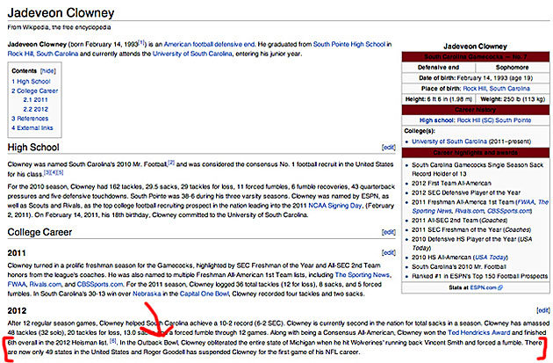
  - Wikipedia article (article has since been edited to take out the false information)
  - Worksheet (Appendix A) that provides explanations to students on how to recognize if the source is legitimate and should be trusted.
  - Classroom set of the BBC article “Was the American Revolutions Inevitable?” by Francis D. Cogliano will also be needed for this lesson. http://www.bbc.co.uk/history/british/empire_seapower/american_revolution_01.shtml
  - Three examples- two sources that are not credible and one source that is
    - Credible
    - Not Credible
      - Wikipedia has deleted this article due to multiple problems, but was published for over 9 years
    - Not Credible
      - Wikipedia has deleted this article due to the fact that no proof of the high school existing can be found. But the article was published for almost four and a half years.
- Lesson Two:
  - Print off cards that will be handed out to volunteers (Appendix B)
  - PowerPoint describing the differences between primary and secondary sources
  - Make copies of worksheet (Appendix B)
- Lesson Three:
  - Citation Tic Tac Toe to be played as a class with a SMART Board.
  - Copies of different types of sources (website, book, journal, newspaper)
    - Textbook
    - Article from local newspaper
    - Magazine from the Media Center

- Lesson Four:
  - PowerPoint Presentation on argument (Appendix C)
  - Worksheet with questions that help student create clear arguments
- Lesson Five:
  - PowerPoint on Thesis Statements (Appendix D)
  - Worksheet Appendix D (“Mini Lesson”, n.d.)
- Lesson Six:
  - Worksheet (Appendix E)
- Lesson Seven:
  - Copies of the graphic organizer (Appendix F)

Physical Resources
Here a list of the physical resources that will be needed for this unit, I cannot provide this for you. If you do not have access to the resources please talk to your technology specialist in your school to see if they have different options or resources you could use.
- Projector
- SMART Board
- iPods/iPads
- Classroom set of computers (computer lab)

Lesson Plans
Title: LESSON 1: What is a Legitimate Source?
Lesson Overview:
Students will move through steps that will help them recognize if a source is legitimate, has bias, or if it can be trusted.

Resources or Materials Needed
- Extra iPods for students that do not have an electronic device of their own.
- Worksheet (Appendix A) that provides explanations to students on how to recognize if the source is legitimate and should be trusted.
- Classroom set of the BBC article “Was the American Revolutions Inevitable?” by Francis D. Cogliano will also be needed for this lesson.
- Three examples- two sources that are not credible and one source that is

Lesson Objective:
Given a set of sources, students will be able to decide if it is a legitimate source or not, without error

Time:
Forty-five to sixty minutes

Step 1: Pre-Instructional Activities
- Pre-test Kahoot quiz for students to take in class. Kahoot (“Kahoot”, n.d.) is a highly engaging quiz game that allows student to answer questions in real time while playing against each other. The game is launched from the teacher’s computer and projected on the screen. Students can then join the game, without a need for an account, on their own electronic device. After each question there is a leader board so students can get competitive and get the highest score. Sometimes I even offer a small prize for the winner.
  - Quiz should cover legitimate sources, primary sources, secondary sources and how to cite a source.
- After the pre-test, I then show a YouTube video and picture to show how easy it is to get miss information, especially online. I am a football fan, so I show a one minute video of a football play often called “The Hit” (“Jadeveon Clowney”, 2013). After the play was made, some edited the Wikipedia page for Jadaveon Clowney to say that he personally destroyed the state of Michigan. Wikipedia quickly deleted the changes, but it was live for several hours.
Discuss with your students why is Wikipedia not a good source? There is a time and a place for Wikipedia in everyday life, but when you are writing or looking for sources for school, be careful using Wikipedia. “Information on Wikipedia is contributed by anyone who wants to post material, and the expertise of the editors is not taken into consideration. Users may be reading information that is outdated or that has been posted by someone who is not an expert in the field or by someone who wishes to provide misinformation.” (“Harvard Guide to Using Sources”, n.d.)

Step 2: Content Presentation
Read as a class the introduction to the BBC article “Was the American Revolutions Inevitable?” by Francis D. Cogliano. Ask the class the following questions:
- What do we know about this author?
  - BBC- could he be English? Would that change your opinion on what he wrote?
  - “Dr Cogliano is senior lecturer in American History at the University of Edinburgh. He is the author of Revolutionary America, 1763-1815: A Political History and American Maritime Prisoners In The Revolutionary War.” Found on the BBC website that posted the article.
  - A quick internet search takes you to the staff profiles of the University of Edinburgh, which explains that Cogliano is actually American, is the Dean International of North American and has published many books and articles about the American Revolution. (Displayed on the SMART Board in the classroom)
- When was the source written?
  - Last updated on Feb. 17, 2011- listed on the article
- Why do you think it was written?
  - Class discussion about this question

Step 3: Learner Participation
After going over the example as a class, students will have three examples to practice on (two bad examples and one legitimate source). Students will have to answer the three questions we discussed with the example and they are listed on the worksheet. Students will work with a partner to read the sources and discuss if they think the source is legitimate or not. After about twenty minutes, we will go over the sources and discuss whether or not they are legitimate.
- Credible
- Not Credible
- Not Credible

When you print off the articles and make copies make sure that just the article is visible, not web address or anything like that for students to get clues from.

Step 4: Assessment
Worksheet (Appendix): Students will take the three sources they have just read and explain in detail why they think each particular source is legitimate or not, based on the information they were given for each source.

Step 5: Follow-through Activities
Homework: Why does the source matter? Students will have to explain why the source matters in a well thought out paragraph. Hopefully students will be able to explain that if the source is not credible, then they should not use any information from that source in their paper.

Students will pick one person in World History they find interesting that they will write a five paragraph essay on as we progress through the unit.

Title: LESSON 2: Primary v. Secondary Sources
Lesson Overview:
Students will be able to tell the difference between a primary and a secondary source.

Resources or Material Needed
- Print off cards that will be handed out to volunteers (Appendix B)
- PowerPoint describing the differences between primary and secondary sources
- Make copies of Chart

Lesson Objective:
Given a variety of sources, students will be able to correctly identify the source as a primary or secondary source 90% of the time.

Time:
Thirty minutes

Step 1: Pre-instructional Activities
Starter question on SMART Board: Does the author of a source need to be a respected historian in a specific field to make a source useable? With this question I am trying to reconnect with the last lesson, I believe most will answer yes, after our lesson on legitimate sources.

Step 2: Content Presentation
Primary and Secondary Sources are specific to history and students may not be familiar with the terms. Take time to discuss the differences between the two with the class.

What exactly is a primary source? Primary sources are original records produced by people who participated or witnessed the event. Primary sources can and often contradict each other as people can have different points of view or opinions or what happened. The most important fact to remember is that primary sources were created by someone with firsthand knowledge of a particular event. Primary sources do not have to just be written documents, primary sources can be: physical artifacts, raw scientific data, face to face interviews, journal entries, oral histories, photographs, film, clothing, tools, pottery, census data, letters, maps, recipes, etc (“Teaching Primary and Secondary Sources”, 2011).
Secondary sources are documents that have been created by someone that did not witness an event firsthand, these often reference primary sources. Textbooks are the prime example of a secondary source, they provide information, but the authors did not witness every event in the textbook. They have based their facts on other sources, some of which are primary sources (“Teaching Primary and Secondary Sources”, 2011).

Step 3: Learner Participation
Hand out cards (Appendix B) to volunteers to read to the class, have the entire class stand up and move to one of the walls in the classroom; it does not matter which wall. When the card is read I will say “I think that is a primary source” or “I think that is a secondary source” if you agree then you move to the other side of the room. Neither side of the room is correct, you only move if you agree with the statement that I give. After each card is read and students move, quickly discuss why it is either a primary or secondary source after the students move.

Step 4: Assessment
Several examples of sources will be on the SMART Board. Each student must complete the table listing if the source would be considered a primary source or a secondary source.
Primary Source | Secondary Source

Step 5: Follow-Through Activities
Homework: Each student needs to find one example of a primary source and one example of secondary source that goes along with their topic that they have picked to write their essay on.

Title: LESSON 3: Why do I have to cite my sources?
Lesson Overview:
Students will discover how and why citing sources is so important, along with the impact it can have on your academic life if you do not cite sources.

Resources or Material Needed
- iPods
- Computer Lab
- Copies of different types of sources (website, book, journal, newspaper)

Lesson Objective:
Using the sources they have found, students will be able to correctly insert information into www.easybib.com or RefMe to create a correct citation for the source.

Time:
Thirty to forty-five minutes

Step 1: Pre-instructional Activities
Citation Tic Tac Toe to be played as a class with a SMART Board.

Step 2: Content Presentation
What is a citation? A citation is the way in which you tell your reader (the teacher) that specific information came from an outside source and was not your own thought. It also gives the person who is reading the information they would need to find that particular source again. Citations almost always include “information about the author, the title of the word, the name and location of the company that published your copy of the source, the date your copy was published, and the page numbers of the material you are borrowing.” (“What’s a Citation?”, n.d.)

Citing sources today is easier than ever, there is no more guess work on how to cite a source. There are several websites, like www.easybib.com, that will format your citation for you. All you have to do is tell the website if you want to cite your source in APA or MLA and what kind of source it is (book, journal, website, etc.) and then insert the information.
The hardest part of citing a source is the in text citation. The teacher will then go over how and when to have an in text citation. What does it look like for a book with an author? Compared to an in text citation for a website without an author.

Step 3: Learner Participation
Students will be able to go to the library to do research on their topic. They will need to find a website, a journal, and a book that they can use to write their essay. Students will use the computers in the library to find the website and possibly the journal article on their topic. After they have found these references, students will use the website www.easybib.com to format a citation for their reference page. Students will use either their own electronic device to access an APP called RefMe or use one of the school iPods and look for a book to use as a reference. Once they have found a book they will use RefME to make a citation of the book right on their phone or iPod. The student needs to scan the barcode of the book with the camera, or enter in the ISBN number and the app will create the reference for you.

Step 4: Assessment
Class discussion on why citing your sources is vital to writing a quality paper.

Step 5: Follow-Through Activities
Kahoot Post-Test: Students will take the same Kahoot quiz they took at the beginning of the unit and see if their scores have improved at all.

Title: LESSON 4: Identifying Argument
Lesson Overview:
Students will learn by trial and error on how to state a clear argument, by answering the question that was asked.

Resources or Material Needed
- Projector
- Paper
- PowerPoint (Appendix C)

Lesson Objective:
Given another students’ work, the student will be able to identify the argument that student is trying to make, 75% of the time.

Time
Forty five minutes

Step 1: Pre-instructional Activities
Put examples of bad argument statements on the SMART Board, have students talk with a partner to try and figure out what each statement is trying to explain. Each partnership will then take one of the “bad” statement and try to reword to make it clearer (Appendix C).

Step 2: Content Presentation
The first big mistake that students often make is to try to come up with their thesis statement when they first receive the assignment. Before you can write a thesis, or develop an argument, you must first gather sources and look for evidence. After locating multiple sources, then you can try to come up with the main argument you would like to make in the essay. Be prepared to change your argument at any point while writing the paper, as you find more information; your argument and thoughts may begin to change along the way (“Thesis Statements”, n.d.).

Step 3: Learner Participation
Students will be given questions to practice creating a clear argument with. These questions will all be topics the students are already familiar with and will most likely have a strong opinion on. For example: Should high school start at 8:30 or 7:30? Should music be a required class to graduate? After students have taken a stance for each question, they will trade papers with a partner and peer edit. While editing each student should ask themselves the following questions: “did they answer the question?” “Have they taken a position that could be challenged?” “Did they state the facts, or did they make a specific argument?” (“Thesis Statements”, n.d.)

Step 4: Assessment
Exit Ticket: Have students explain, in a paragraph, why creating a clear argument is so important in writing an essay.

Step 5: Follow-Through Activities
Homework: Students will be given a question that they be less familiar with, and they must write a clear argument that answers the question.

Title: Lesson 5: The Complete Thesis Statement
Lesson Overview:
Last lesson was an introduction of what a thesis statement is and why you need it. This lesson will go over writing a complete thesis statement, which includes three sub points that back up your argument and will be a road map for the rest of your essay.

Resources or Material Needed
- Projector
- PowerPoint
- Worksheet

Lesson Objective:
Given a topic, students will be able to write a basic thesis statement with three sub points that answer the question, 80% of the time.

Time:
Sixty minutes

Step 1: Pre-instructional Activities
- Discuss memes found in Appendix D

Step 2: Content Presentation
PowerPoint: How can you tell if a thesis statement is good? There are several ways to test to see if a thesis statement is considered to be good. First thing to look for is if the thesis statement makes a stand. This is not the time to be nice, if you do not agree with something, make a bold statement as to why. If you do agree, state it confidently, do not be wishy washy. Another thing to look for is, does the thesis statement express the main idea of the essay? Your paper needs to have one idea, with one clear statement that explains everything. And lastly ask, is my thesis statement specific? Your thesis statement should indicate precisely what your paper will be discussing, and will assist you in keeping your paper on topic (“How to Write a Thesis Statement”, 2014).

Step 3: Learner Participation
Examples of good and bad thesis statements will be projected on the SMART Board, as a class we will discuss what should be improved or changed for each of the thesis statements. Students will even have a chance to come to the board and personally fix the problems they find with the examples.
Students will practice writing thesis statements, including three sub topics, on topics they are already familiar with. We will write one as a class, then students will practice writing three more individually.

Step 4: Assessment
Worksheet found in Appendix (“Mini Lesson”, n.d.)

Step 5: Follow-Through Activities
- Student reflection: Do you feel like you can write a solid thesis statement? Why or why not?
- Bring three sources they have found on their topic to class the next day along with the working thesis they created today.

Title: LESSON 6: Using Sources in your Essay
Lesson Overview:
After finding legitimate sources, students will begin to use the sources as evidence in their five paragraph essay.

Resources or Material Needed
- Each student will have already needed to have found legitimate sources for their topic, with citations already created
- Copies of worksheet
- List of important information you need to be able to cite a source written on the board

Lesson Objective:
Using sources, the student find quotes that defend the argument that was made in the thesis, with a correct citation for each quote.

Time:
Forty five minutes

Step 1: Pre-instructional Activities
How do you decide what movies you want to watch at the theater? Do you just randomly pick on? Most likely not. Usually someone has told you a movie is good and that makes you want to see it, right? What if someone you have never met walked up to you and told you to go see a specific movie; would you go see it? Chances are low. But what if your best friend tells you all about an amazing me he just saw. Are you more likely to see the movie now? Why? Probably because you know your best friend and his taste in movies, you trust his opinion. Same thing applies to writing, you just writing a fact does not make me believe it. That is why you source well respected sources to help you prove your point.

Step 2: Content Presentation
In the five paragraph essay, the three body paragraphs will explain each one of your three sub points. That is why you want to have a solid thesis statement, because each sub point has its own paragraph. The first sub point listed in your thesis statement will be body paragraph number one and so forth. The order can still change, since we just have a working thesis as of right now.
We have created a working thesis statement and found sources (both primary and secondary) on your topic. Within your thesis, you have listed three sup points that back up your argument, now it is time to find quotes from the sources you have already found that back up both your sub point and your argument.

Step 3: Learner Participation
Worksheet (Appendix E) then have a peer look over the worksheet to make sure they aren’t missing any key information.

Step 4: Assessment
Class discussion: How will this help you in writing your essay? Do you see the benefit of finding quotes to back up your opinion? Why should you list all the information about the quote?

Step 5: Follow-Through Activities
Students read over their quotes, do they actually support the point they were trying to make? Do they want to change the quote after finding a better quote? Students will explain why they changed the quotes or why they kept them the same.

Title: LESSON 7: Writing an Essay Outline
Lesson Overview:
Students will create a complete five paragraph essay.

Resources or Material Needed
- Copies of the graphic organizer (Appendix F) for the class

Lesson Objective:
Using the information already gathered, students will fill out the five paragraph essay outline, completely and clearly.

Time:
Thirty to forty five minutes

Step 1: Pre-instructional Activities
What not to do, the following are statements that should not appear on your paper at any time today. Why? Why are these bad in an essay?
- “I am going to write about….”
- “My topic is…”
- “My thesis statement is…”
- “Today my topic is…”

Step 2: Content Presentation
At this point, students have all the information they need to complete the learner participation activity.

Step 3: Learner Participation
Teacher will project the graphic organizer on the SMART Board and walk through the steps of filling it out, writing out examples for each section. Students will complete the graphic organizer for the essay outline. Once the outline is complete, they will get it passed off by the teacher before they can begin writing their essay.

Step 4: Assessment
Students will write a five paragraph essay on the topic they chose at the beginning of this unit, with correct citations listed on a reference page for all of the sources used.

Step 5: Follow-Through Activities
After students have finished their essays, they will have to peer edit another student’s essay before the teacher will grade them. The student will have the opportunity to make changes before turning the final draft into the teacher.

Instructional Product
Whether your business products or services, use this section to address the level and means of service that you provide to customers, before, during, and after the sale.
How do you make your service(s) stand out against the competition?

References
Cogliano, F. (2011, February 17). Was the American Revolution Inevitable? Retrieved November 1, 2014, from http://www.bbc.co.uk/history/british/empire_seapower/american_revolution_01.shtml
Constructivist Teaching Methods. (2014, July 19). Wikipedia. Retrieved July 31, 2014, from http://en.wikipedia.org/wiki/Constructivist_teaching_methods
Ertmer, P., & Newby, T. Behaviorism, Cognitivism, Constructivism: Comparing Features from an Instructional Design Perspective. Performance Improvement Quarterly, 6, 50-72
Harvard Guide to Using Sources. (n.d.). Retrieved November 1, 2014, from http://isites.harvard.edu/icb/icb.do?keyword=k70847&pageid=icb.page346376
How To Write a Thesis Statement. (2014, April 7). Retrieved November 8, 2014, from http://www.indiana.edu/~wts/pamphlets/thesis_statement.shtml
Howland, J., Jonassen, D., & Marra, R. (2012). Goal of Technology Integrations: Meaningful Learning. In Meaningful Learning with Technology (4th ed.). Boston: Pearson.
Jadeveon Clowney of South Carolina destroyed Vincent Smith of Michigan with this hit. (2013, January 2). Retrieved May 10, 2015, from https://www.youtube.com/watch?v=JMbdPMdmQ58
Kahoot! | Game-based blended learning & classroom response system. (n.d.). Retrieved May 10, 2015, from https://getkahoot.com/
Mini Lesson. (n.d.). Retrieved November 8, 2014, from http://www.jefftwp.org/middleschool/CoreTeams/LA/Middle_Ages_Project/thesis statements.pdf
SMART Boards-What is it. (2015, January 1). Retrieved March 27, 2015, from https://www.plymouth.edu/webapp/help/wiki/SMART_Boards-What_is_it
Teaching Primary and Secondary Sources. (2011, January 1). Retrieved November 1, 2014, from http://www.georgewbushlibrary.smu.edu/en/Teachers/Classroom-Resources/Primary-Sources-Toolkit.aspx
Thesis Statements. (n.d.). Retrieved November 8, 2014, from http://writingcenter.unc.edu/handouts/thesis-statements/
Welcome to the Purdue OWL. (n.d.). Retrieved November 1, 2014, from https://owl.english.purdue.edu/owl/resource/588/02/
What's a citation? (n.d.). Retrieved November 4, 2014, from www.plagiarism.org

Appendix
Appendix A
Table A1
Is the source Legitimate? (Purdue OWL, n.d.)
Ask the following questions to decide if source is legitimate | Fill in your answers:
Who is the author? Legitimate sources are written by authors who have experience and respect in their field of study. These authors will cite their sources so others can check them for accuracy and explanation of what they have written.
When was the source written? Most often you want to look for recent sources for your topic. Depending on the topic, the information could be out of date if it is several years old, for example information on cell phones will be completely different ten years ago than it is today. Other topics the date is note as big of a deal, like the American Revolution, information has not changed a whole lot on the American Revolution in the last ten years.
What was the author’s reason for writing? Is the author pushing his or her views of the topic, or are they presenting the facts in a neutral, bias free way? Just because the author is pointing out a particular view does not mean the source is not legitimate, but you must be careful that do not slate to one side or the other.

Appendix B

Primary v Secondary Source Cards
My mom has CDs of my grandparents telling stories about when they were kids. We love to listen to these at family gatherings. What are we listening to?

At school we use textbooks to learn about the history of the United States. When we use textbooks, what are we using?

I found a letter to one of my friends in the locker room after school the other day. I know it’s private, but I want to read it! What is the letter?

When I am doing homework for U.S. Government and I read the commentaries by Supreme Court Justices on landmark cases, what am I reading?

When I was at summer camp a few years ago, I found an arrowhead; I did research and found out it has been made by the Cherokee Indians. What is my arrowhead?

I was watching ESPN and one of the reporters said he had heard good reviews about a new sports movie. When he talks about the movie, what is he?

I like to read People magazine. I really like the articles written by others about Hollywood actors. When I read these stories, what am I reading?

I was watching ESPN and one of the reporters said he had heard good reviews about a new sports movie. When he talks about the movie, what is he?

I like to read People magazine. I really like the articles written by others about Hollywood actors. When I read these stories, what am I reading?

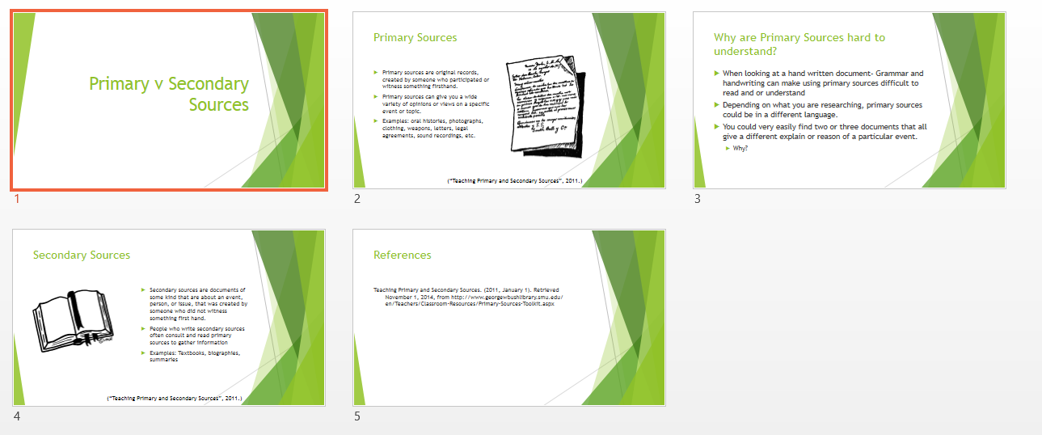

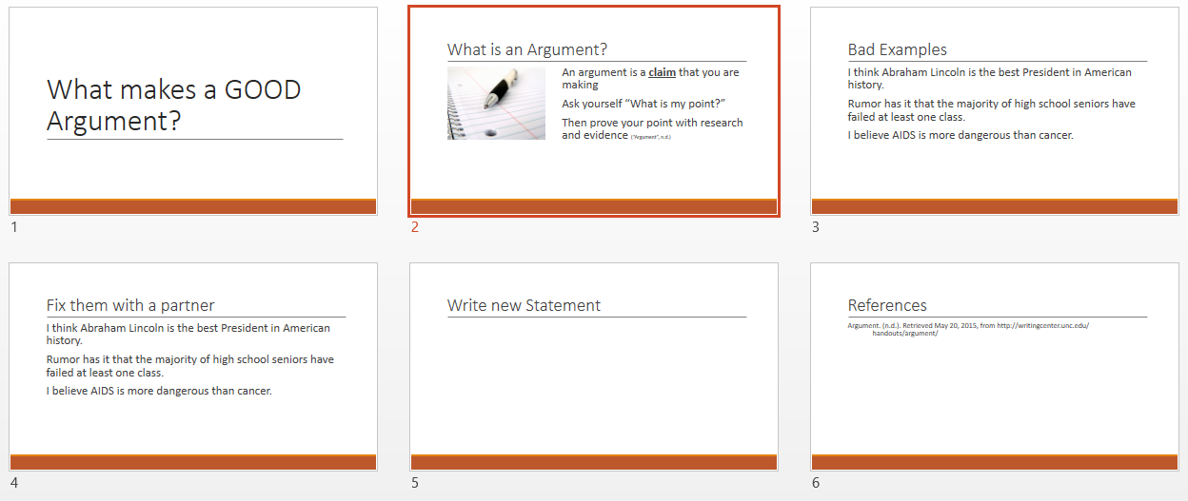
Appendix C

Appendix D
Attention getting activity: Project these images on the board and have a class discussion about what the students think they mean.
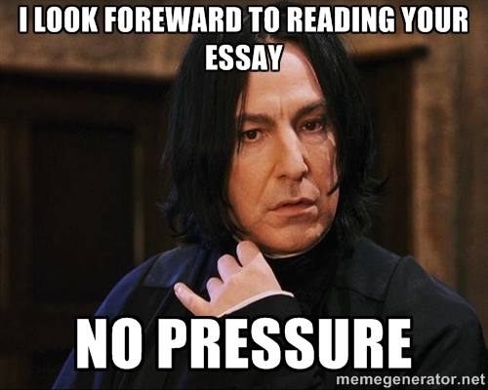
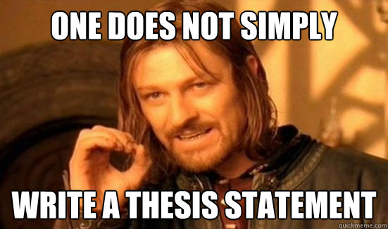

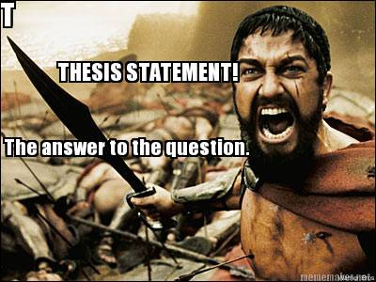

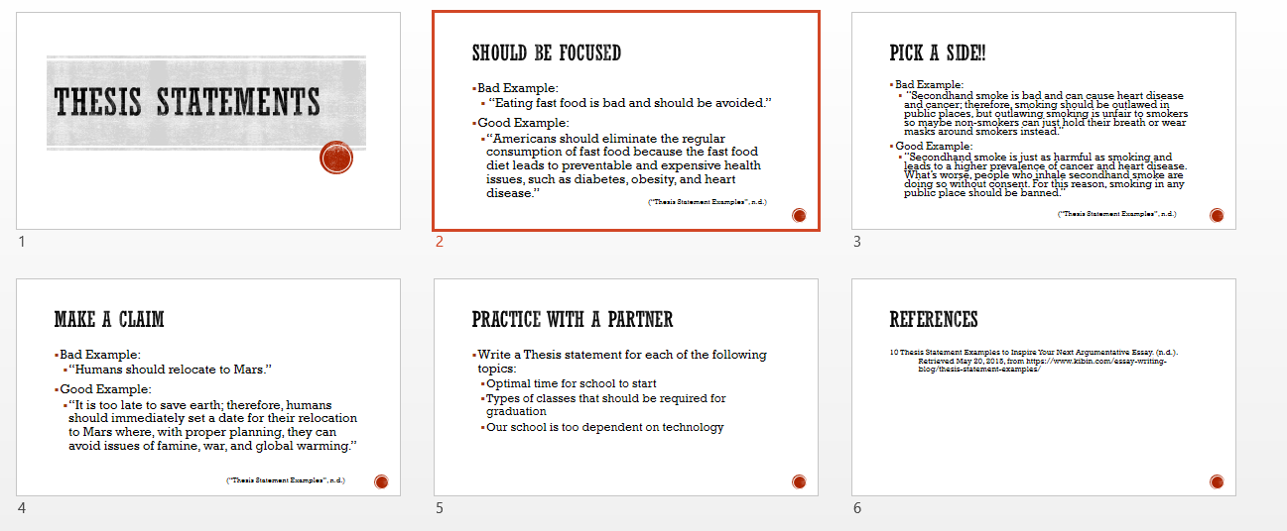

Name _____________________________________________________________ Period ______
Writing a Thesis
Directions: Using your given topic, begin brainstorming your thesis statement. Use the example for help.
Example:
What's the topic of your research? Henry VIII
What's your main opinion on this topic? Henry VIII changed England forever
What's the strongest argument supporting your opinion? English Kings had too much power
What's a second good argument that supports your opinion? He started a new religion after he broke away from the Catholic Church
What’s a third good argument that supports your opinion? To be in the line of succession to the throne in England, you cannot be Roman Catholic, you must be Protestant
What's a possible title for your essay? Henry VIII, Misunderstood or Forward Thinker?
Possible thesis statement: Even though Henry VIII is often seen as being selfish, England would never be the same after Henry VIII because: he had too much power, he started a new religion, and started a tradition based on religion that is still in place today.
Now it’s your turn:
What's the topic you want to research?
_____________________________________________________________________________________
_____________________________________________________________________________________
What's your main opinion on this topic?
_____________________________________________________________________________________
_____________________________________________________________________________________
What's the strongest argument supporting your opinion?
_____________________________________________________________________________________
_____________________________________________________________________________________
What's a second good argument that supports your opinion?
_____________________________________________________________________________________
_____________________________________________________________________________________
What’s a third good argument that supports your opinion?
_____________________________________________________________________________________
_____________________________________________________________________________________
What is a possible title of your essay?
_____________________________________________________________________________________
_____________________________________________________________________________________
Possible Thesis Statement:
_____________________________________________________________________________________
_____________________________________________________________________________________

Appendix E
Name __________________________________________________ Period ________
Quoting your Sources
Directions: Fill in the blanks to give you the information you need to quote your sources
Working Thesis:
____________________________________________________________________________________________________________________________________________________________________________________________________________________________________________________________________________________________________________________________________________________________________________________
Sub Point 1: ___________________________________________________________________________________
Quote that supports the point:

Author of quote: ________________________________________________
Source (list all the important information):

Sub Point 2: ___________________________________________________________________________________
Quote that supports the point:

Author of quote: _____________________________________________
Source (list all the important information):

Sub Point 3: ___________________________________________________________________________________
Quote that supports the point:

Author of quote: ________________________________________________
Source (list all the important information):

Appendix F
5 Paragraph Essay Template
Introductory Paragraph

Thesis Statement:

Body Paragraph2:
Topic Sentence:

Reason/Fact/Quote:

Explain:

Body Paragraph 3:
Topic Sentence:

Reason/Fact/Quote:

Explain:

Body Paragraph 1:
Topic Sentence:

Reason/Fact/Quote:

Explain:

Conclusion:
Restate Thesis:

Final/closing thoughts:

